Electrical Lighting Controls Schedule

Revision Date Description Created Checked
T1 2 Tender Issue
Schedule of Equipment – Commercial fit out

Code |  | Description | iLight Series | Product Code | Image |  | Areas
CP1 | Metal Control Plate-  Configurable button sizes & engraving, brushed stainless |  | iLight Enterprise | Sencia  Range | 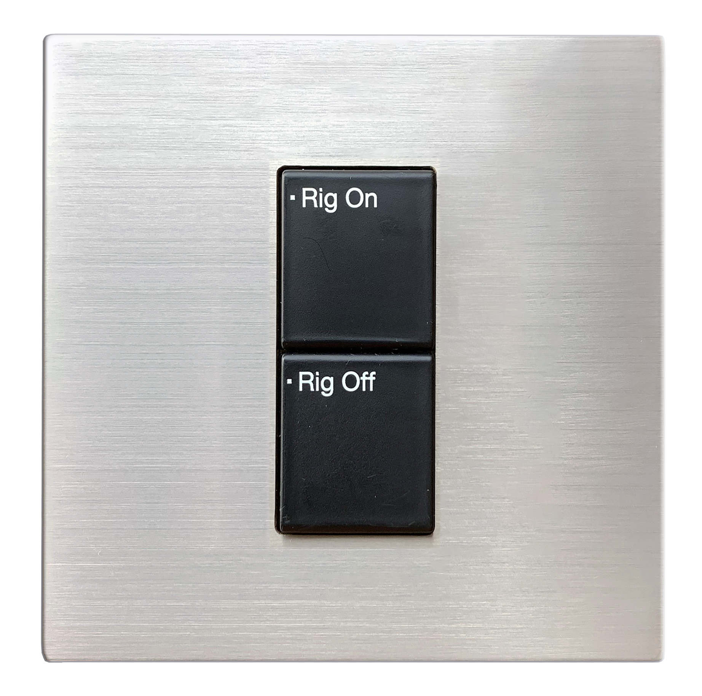 | Meeting Rooms
CP2 | Metal Control Plate-  Configurable button sizes & engraving, brushed brass |  | iLight Enterprise | Sencia  Range | 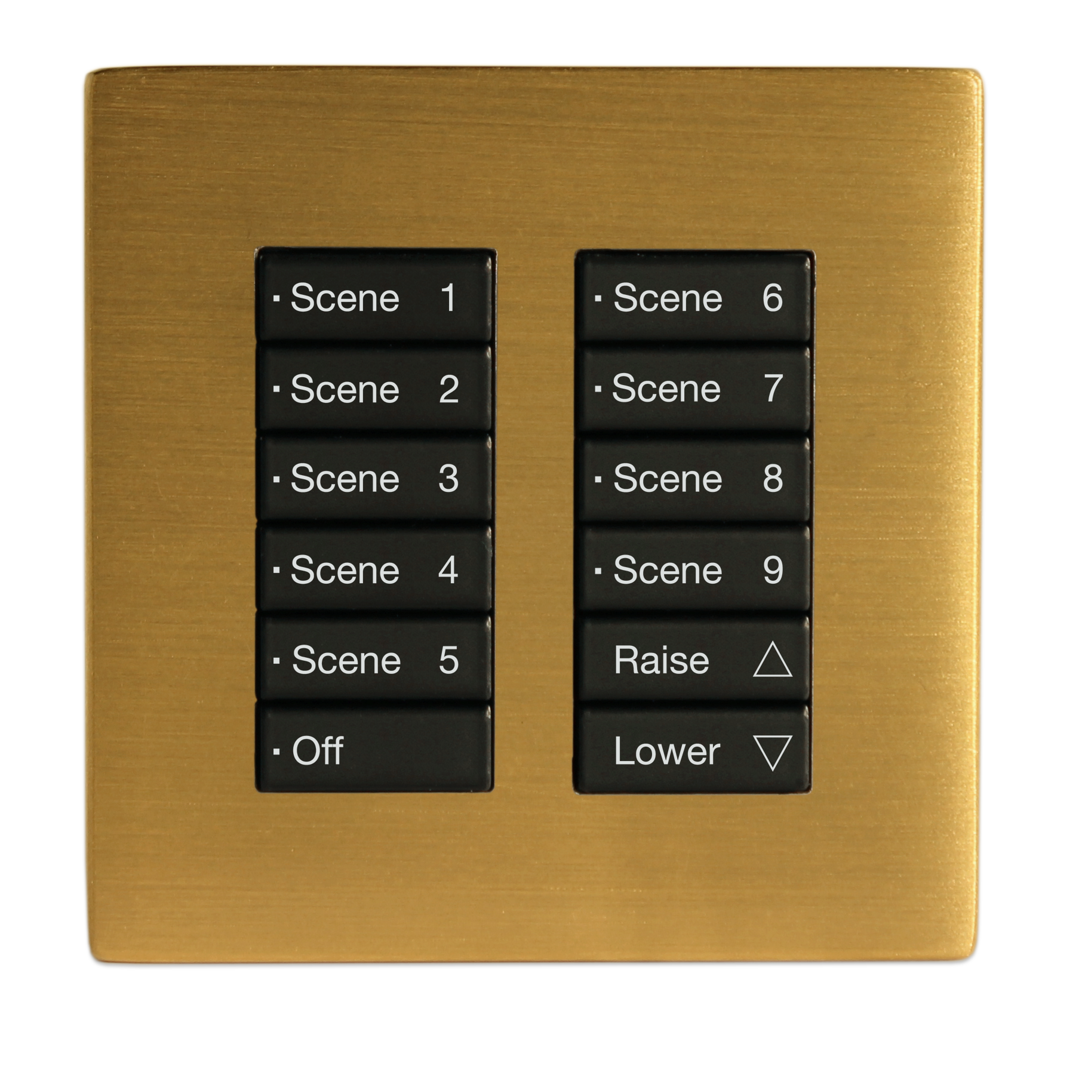 | Meeting rooms
CP3 | Metal Control Plate-  Configurable button sizes & engraving, brushed chrome |  | iLight Enterprise | Sencia  Range | 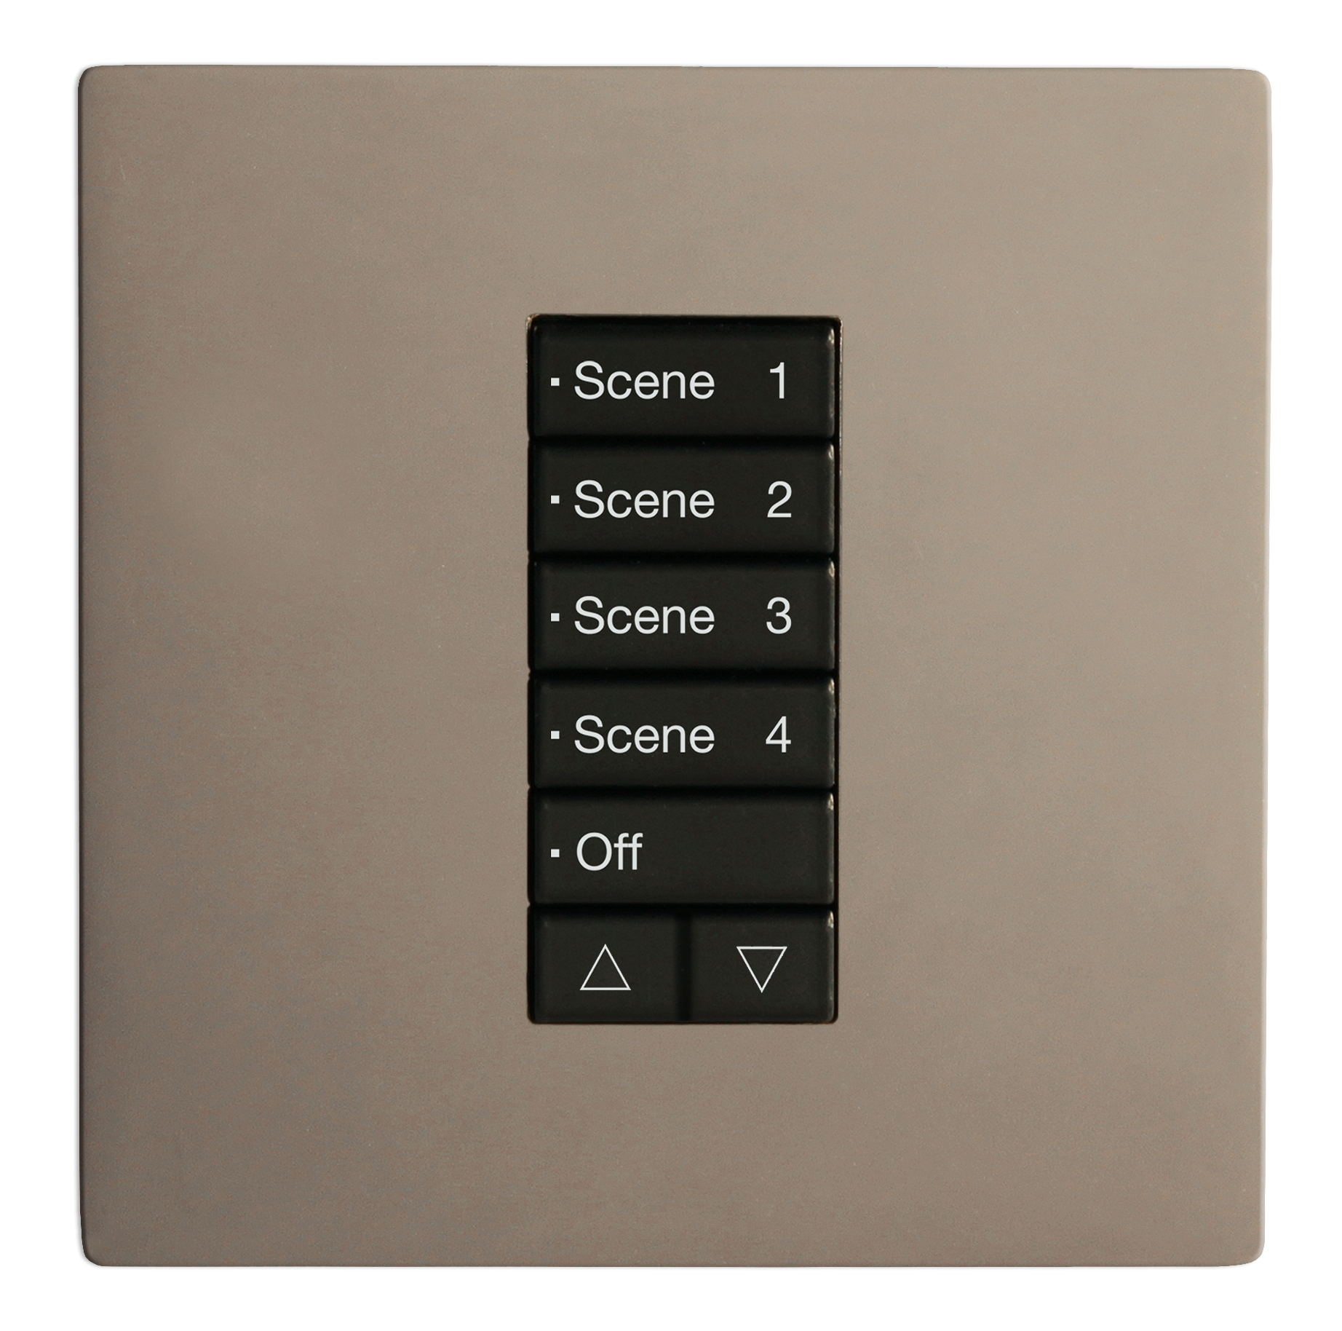 | Meeting rooms
CP4 | Metal Control Plate-  Configurable button sizes & engraving, brushed satin |  | iLight Enterprise | Sencia  Range | 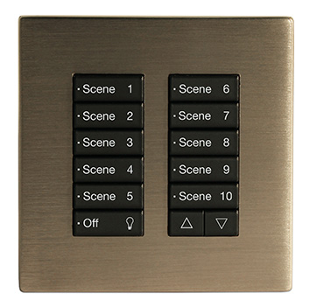 | Meeting rooms
CP5 | Metal Control Plate-  4 Button  Raise up/down |  | iLight Enterprise | Classic  Range | 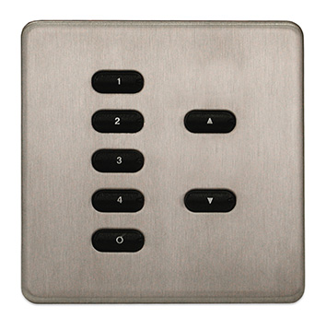 | Meeting rooms
CP6 | Plastic DALI Control Plate  White |  | iLight Enterprise | CLD Range | 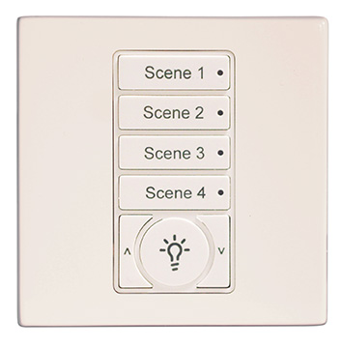 | Meeting rooms
CP7 | Plastic DALI Control Plate  Black |  | iLight Enterprise | CLD Range | 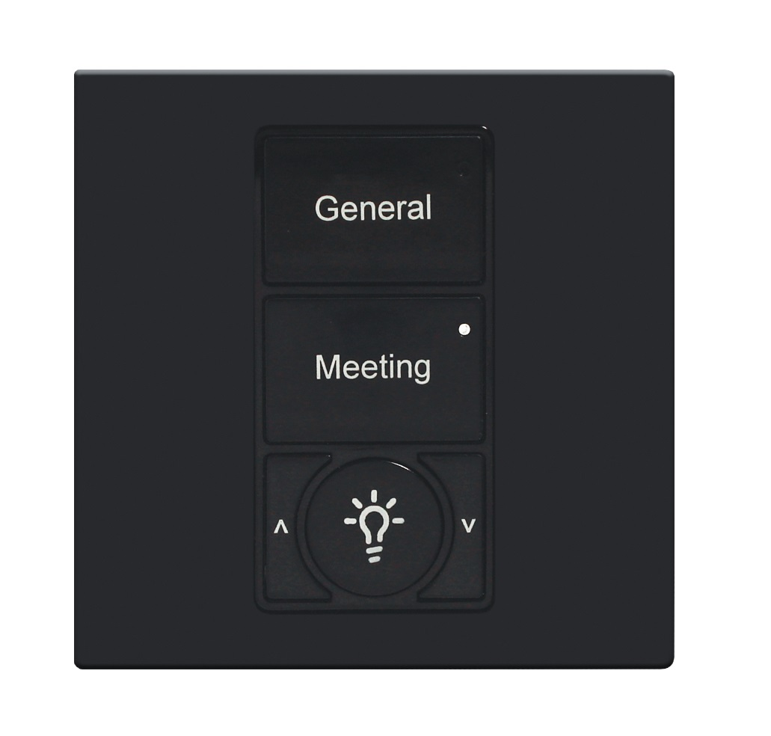 | Meeting rooms
TS1 | 8” Multiroom Colour Touchscreen |  | iLight Enterprise | TSE80 | 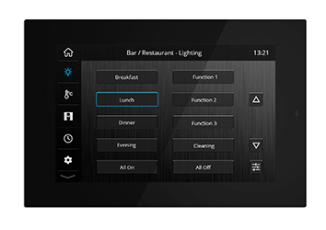 | Reception, meeting rooms or central controller
TS2 | 5.5” Multiroom Colour Touchscreen |  | iLight Enterprise | TSE55 | 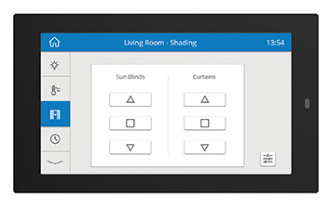 | Reception, meeting rooms or central controller
APP | iLight App  Lighting, HVAC, Shading |  | iLight Enterprise | TSEtouch | 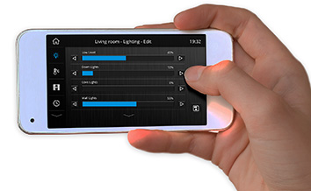 | Remote access/meeting rooms for end user applications
TS3 | 4” Colour Touch Screen for HVAC-1 Lighting, HVAC & Shading |  | iLight Enterprise | TSG40 | 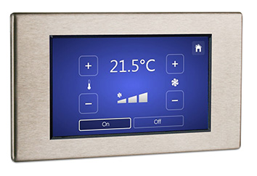 | Meeting rooms
PC1 | Enterprise Operate |  | iLight Enterprise | AX-PCSM1 | 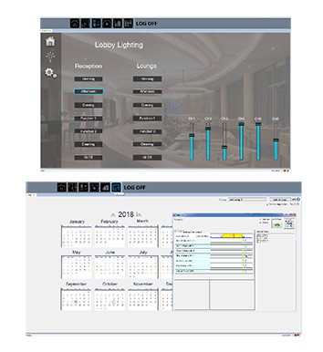 | Timed events & scene recall

