Electrical Lighting Controls Schedule

Revision Date Description Created Checked
T1 2 Tender Issue
Schedule of Equipment – Stand Alone - iLight Solo Applications

Code | Description | iLight Series | Product Code | Image | Areas

MB | 10 output, 6 pole marshalling box | iLight Solo | LCC-10 | 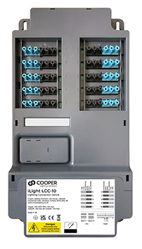 | Open plan offices/meeting rooms
PD1 | Absence/  Presence detector 230V | iLight Solo | PPAD-C-230V | 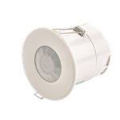 | Switching applications
PIR lead 1 | For connection to PIR PPAD-C-230V | iLight Solo | SL-6P-4C-3M  or  SL-6P-4C-5M | 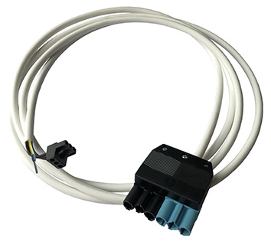 | Suspended ceiling
PD2 | DALI Absence/  Presence detector 230V | iLight Solo | PPAD-C-DALI-230V |  | DALI dimming applications
PIR lead 2 | For connection to PIR  PPAD-C-DALI-230V | iLight Solo | SL-6P-5C-3M  Or  SL-6P-5C-5M | 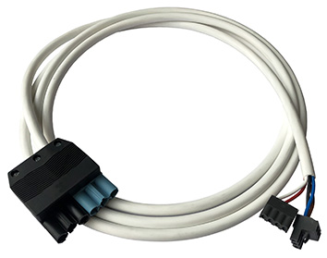 | Suspended ceiling
Luminaire leads | 3,4,5, & 6 core leads | iLight  Enterprise / Solo | Various | 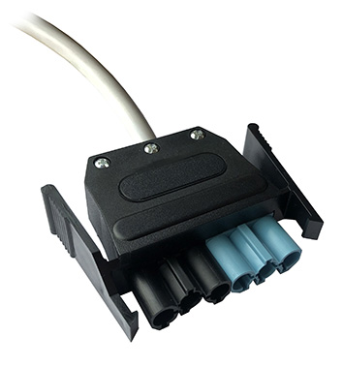 | Suspended ceiling
Luminaire  plugs | Standard & emergency | iLight  Enterprise / Solo | Standard  ACCPL-6P-01-B  Emergency  ACCPL-6P-01-R | 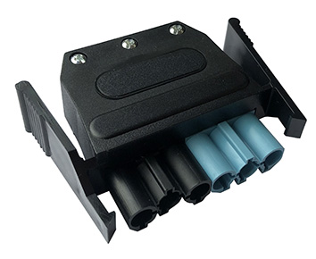 | Suspended ceiling
HS1 | Full programming Handset | iLight Solo | HHIR-LCD-PROG | 