Electrical Lighting Controls Schedule

Revision Date Description Created Checked
T1 2 Tender Issue
Schedule of Equipment – Single floor hard wired

Code | Description | iLight Series | Product Code | Image | Areas
LCM1 | 2 Universe DALI Controller  (128 addresses) | iLight  Enterprise | SCMD2 | 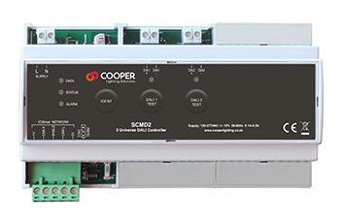 | Open plan office/meeting room
LCM2 | 4 Universe DALI Controller  (256 addresses) | iLight  Enterprise | SCMD4 | 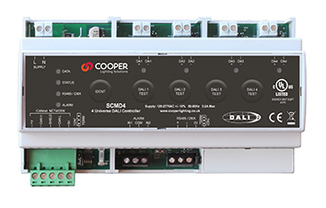 | Open plan office/meeting room
P1 | Miniature DALI PIR/Photocell, 32mm cut out, for integration into a luminaire | iLight Enterprise | PPAD- C-MB-DALI ADDR | 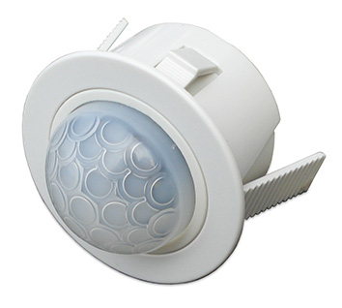 | Recess, Luminaire or Besa integrated
P2 | HB DALI Ceiling mount PIR/photocell, 64mm cut out | iLight Enterprise | PPAD-C-HB-DALI-ADDR | 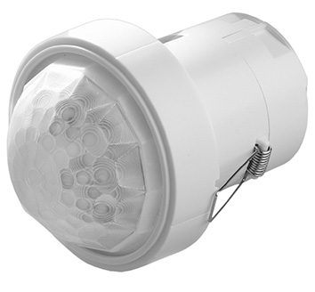 | High Bay - Atriums & Warehouses
FD1 | DALI field relay  On of/off control | iLight Enterprise | FLTS | 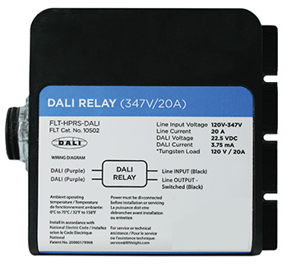 | For control of non-dimmable luminaires via DALI
CP1 | Plastic DALI Control Plate White | iLight Enterprise | CLD Range | 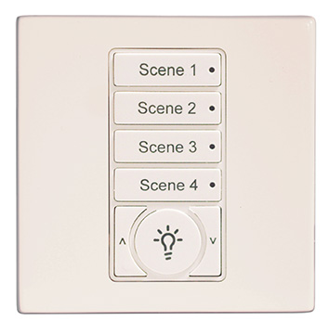 | Meeting rooms
CP2 | Plastic DALI Control Plate Black | iLight Enterprise | CLD Range | 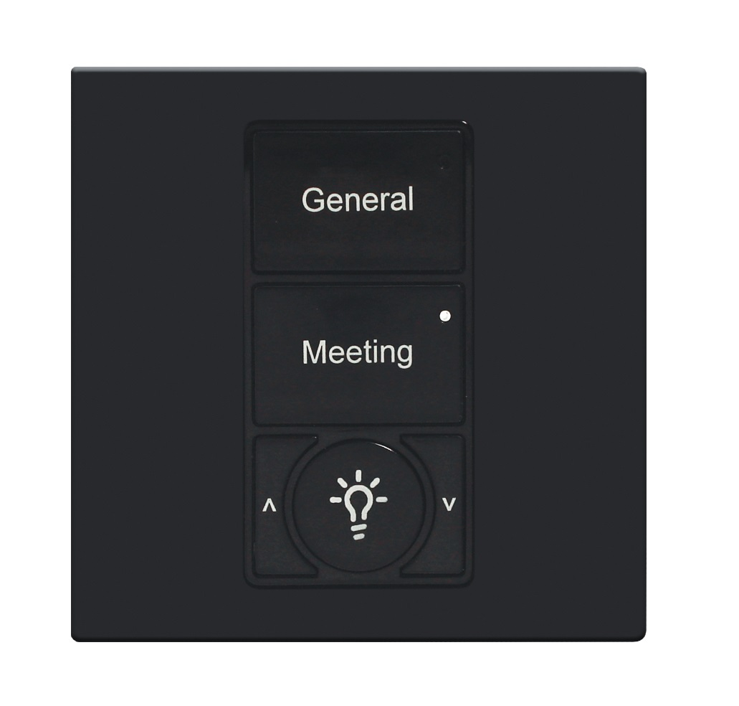 | Meeting rooms
UI-1 | DALI Input Unit | iLight Enterprise | DALI-I-U | 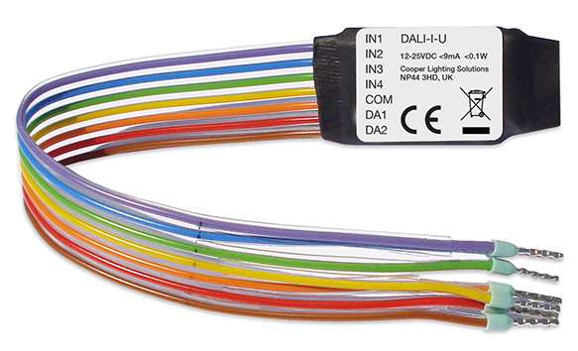 | Switch input module via DALI
TS1 | 8” Multiroom Colour Touchscreen | iLight Enterprise | TSE80 | 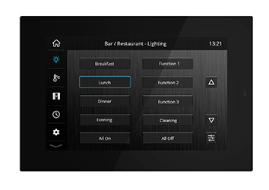 | Reception, meeting rooms or central controller
TS2 | 5.5” Multiroom Colour Touchscreen | iLight Enterprise | TSE55 | 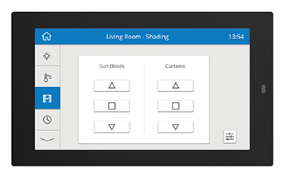 | Reception, meeting rooms or central controller
UI-2 | Mini Universal Interface  For Room Partition | iLight Enterprise | UIM | 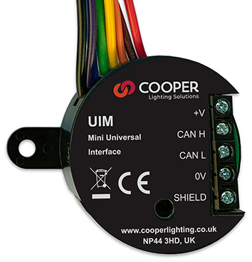 | Connection of switch contacts to CAN and room partition switches

